 | 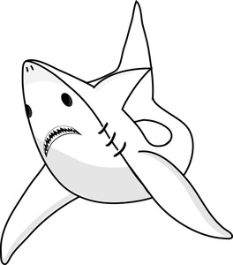 | 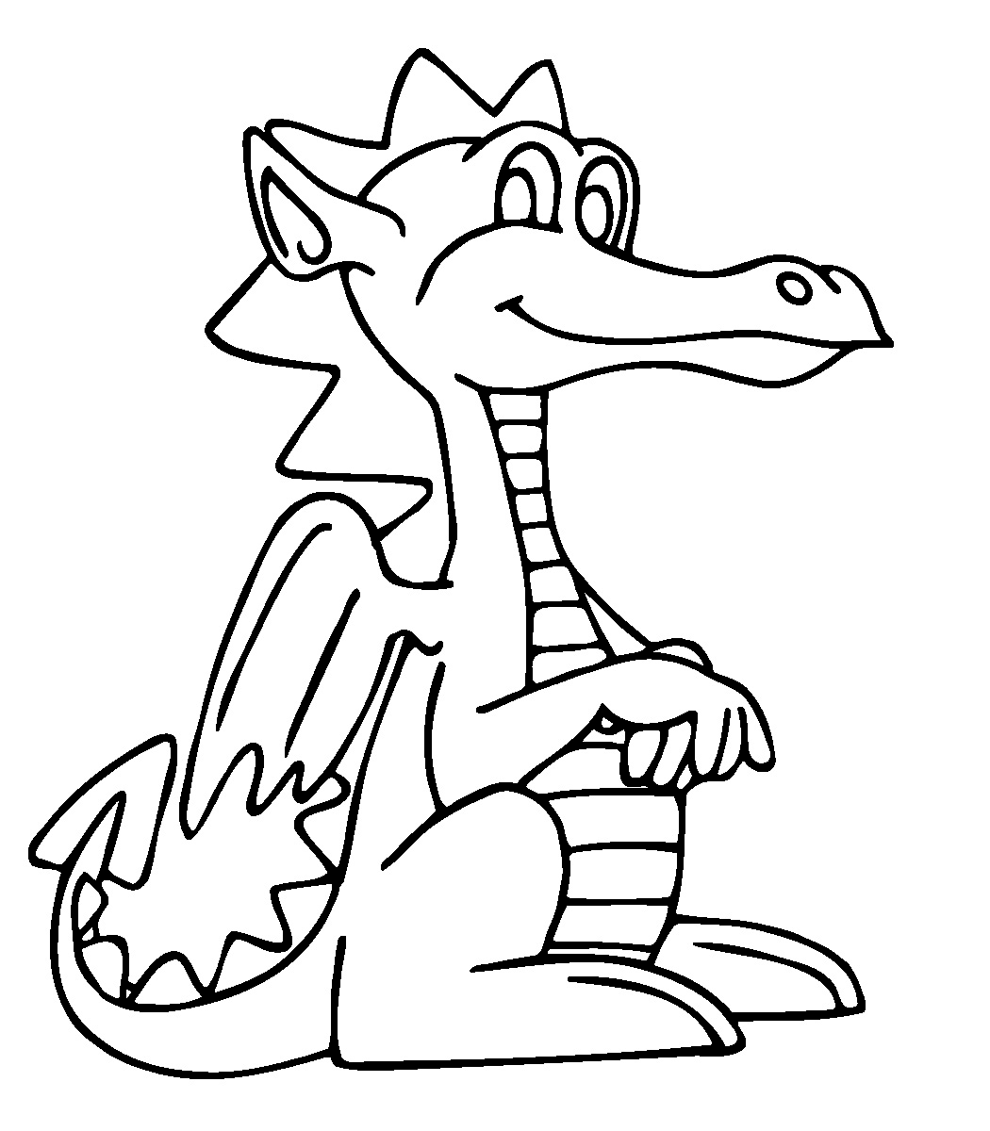
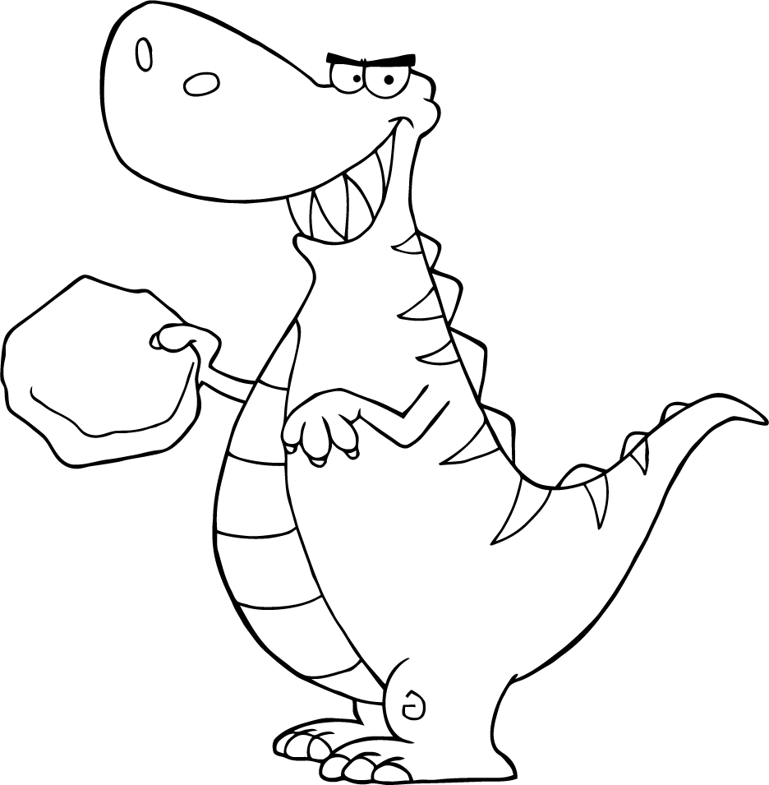 | 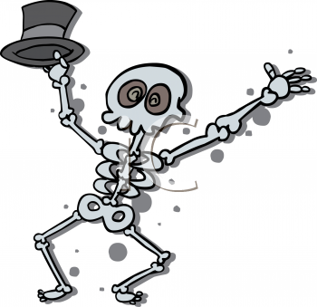 | 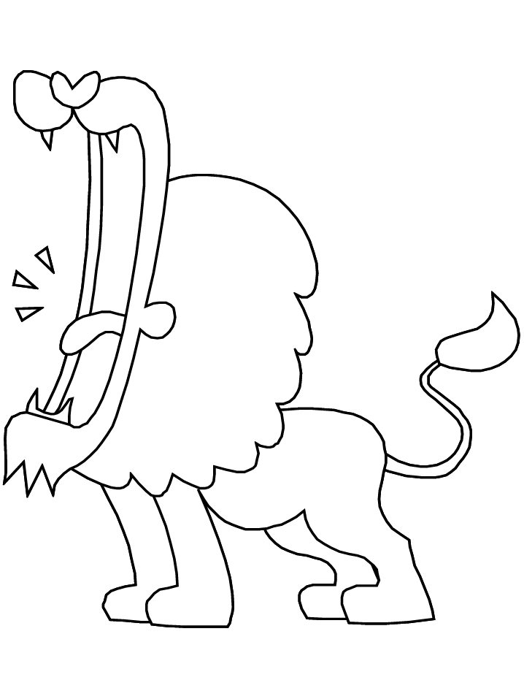
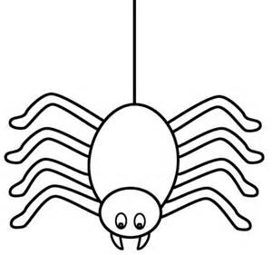 |  | 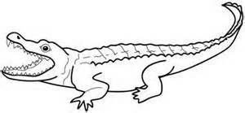

1. | 2. | 3.
4. | 5. | 6.
7. | 8. | 9.

Name_____________________

I’m not scared of ____________________________________________________
--------------------------------------------------------------
____________________________________________________
Or
____________________________________________________
--------------------------------------------------------------
___________________________________________________.
I hear a knocking on my door!
Oh No it’s
___________________________________________________
-------------------------------------------------------------
___________________________________________________

